One Awards Community Study- Cyclone Idai

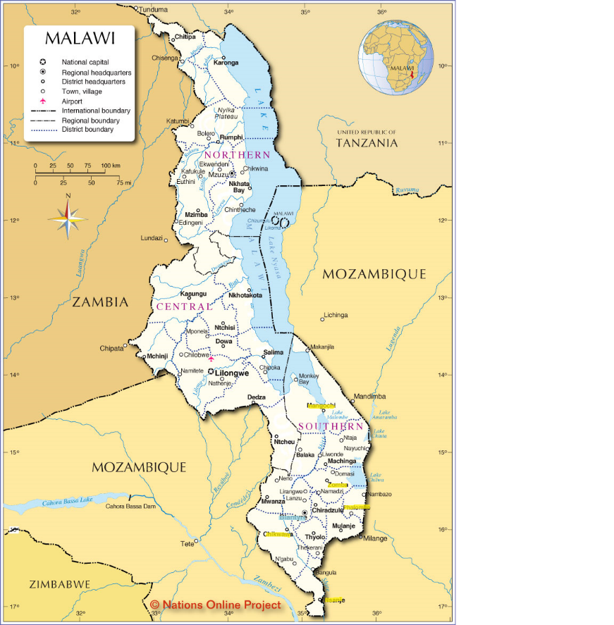

In early March this year (2019) the Southern African countries Malawi, Mozambique and Zimbabwe were hit by a tropical cyclone which killed hundreds of people and left hundreds and thousands more affected. Cyclone Idai first hit the Mozambican city of Beira on 15th March 2019 and very quickly reached the southern part of Malawi destroying infrastructure, crops and livestock. In Malawi the government has confirmed 59 dead, 867,000 people affected, 87,000 people missing and 18,000 homes destroyed. Some of the larger districts in Southern Malawi that were mostly affected by the cyclone were Zomba, Mangochi and Phalombe. However, Chikwawa and Nsanje are the country’s lowest lying districts and are next to the Shire River, the largest river in Malawi and leading to the Zambezi, and were therefore hit worst. During my year away with Project Trust I lived and worked in Bangwe, a township of Blantyre. Blantyre is one of the larger districts in southern Malawi and fortunately wasn’t as badly affected by the cyclone. However, the majority of the houses in the villages of Bangwe and where I lived are made from mud bricks and are very weak. With the heavy rains and strong winds many houses could not with stand the forces and cracks in the walls would form and eventually walls would collapse and some houses would fall down. As Bangwe wasn’t hit the worst, many charities and organisations focused their time and efforts with disaster relief elsewhere, and so support to people that needed it in the villages near me was left to themselves.

As a member of Post Test Club, a youth club at my host organistation, Umunthu Foundation, I heard from one of the other members that one of the walls of his house had fallen down and that he was needing help to buy plastic sheeting to cover one side of his house to protect it from further collapse, and from the rains that were to continue. Hearing this, and seeing the devastation of the cyclone and the flash floods in my home village, really hit home and made me want to help my community, be it as little as providing plastic sheeting for one house. At the end of one of the PTC sessions a few of the members put together a plan to fundraise some money to buy plastic sheeting for his house and also help the community by providing plastic sheeting for other houses in the community. As a group, all of the members in PTC put in a little bit of money towards purchasing plastic sheeting to hand out to families in my village (William village) and the neighboring village whose houses had partly fallen down or had large cracks in the walls. We hoped to prevent them from falling down in the storms. Over two weekends, we were able to hand out 25metres of plastic sheeting each to 30 families in the two villages.

Whilst handing out the plastic sheeting and venturing further into the villages it became clear that plastic sheeting would not be enough to help families who had become homeless because their houses had been completely destroyed by the cyclone. There were families who would need to find somewhere else to live until they could find enough money to rebuild their house. One house and family that stuck out in needing the most help, and really hit us all hard, was a big family with many young children. Their house had been completely destroyed and providing them with plastic sheeting would be no help. This had also become the case with Trickseen’s house, the member from PTC, as the continuing rains had meant his house completely collapsed. We really wanted to do more and had the idea to fundraise more money for local disaster relief and put the money towards rebuilding Trickseen’s house. The majority of people in Malawi will be living on very little and so when a natural disaster, like Cyclone Idai, hits it can be extremely hard to get back on your feet and back to how you were living before. Many families will be homeless for long periods of time and will have to save up for months, maybe even years to rebuild their houses. To put it into perspective, at the primary school I volunteered in, the standard salary for a teacher is 40mk (just under £40) per month, £480 a year. Each month this would have to be put towards school fees, food for the month (nsima and relish, the staple food in Malawi), electricity bills, transport etc, leaving very little, if any, money to put towards rebuilding their home.

Together with my two partners Rachel and Kirsty, we each put up a Facebook post explaining what had happened, how the cyclone had affected us and our community and how people could help. The response we got was amazing and within about two weeks we had managed to raise just over £2,500. The money we raised would be enough to rebuild Trickseen’s house (a bedroom, living area and a small veranda the same size as his previous house) and then any remaining money would go towards helping the community with disaster relief work.

Below is part of the post I put up on my Facebook a week after the cyclone first hit Malawi.

“*Unfortunately, a close friend, and a member of PTC's, house has collapsed during last week's flash floods and we would all love to help him rebuild his house! One brick costs 15 kwacha, only 1.5p in the UK, and one bag of cement is around 7500 kwacha, equivalent to £7.50. Although this may not seem a lot to everyone back at home this is a lot of money for a Malawian family living in a rural village like William.*

*Therefore, I am asking people at home if they would like to support PTC and the fundraising for our local community by donating, even if it were to be buying one brick or one bag of cement! If you would like to donate any money and help a small village very close to my heart and somewhere that would not be getting support otherwise, please do get in touch and I can give you my bank details so that you can transfer money. That way I am able to take the money out in kwacha and put it straight towards buying bricks and cement.*

*With the money we fundraise we will prioritise rebuilding our friend's house first and then we will be buying materials for rebuilding some of the most damaged houses in William village. Money will also be put towards buying perishable foods and goods for the families affected close to home. We feel that as so many people have been affected by the flash floods in Malawi and as we can’t help everyone it would be best to focus on helping those closest to home and our local community.*

*Again, thank you for all the generous support back at home in the UK, everyone here is incredibly grateful and we wouldn't be able to help as many people without you!” (17/03/19)*

The rebuilding of Trickseen’s house started the following month, as we wanted to wait until we were sure the storms had passed and the rainy season was coming to an end. In Malawi they have two main seasons: rainy season (November to April/May) and dry season (June to September/October). Trickseen’s house is half way up Bangwe Mountain, so the first steps were to dig the foundations deep into the ground so that his new house would be more sturdy and therefore able to withstand strong winds. We hoped it would be less likely to fall down in the future during any other tropical cyclones that may hit Malawi over the years. We also decided to buy better and higher quality bricks and cement, rather than use traditional mud bricks and sand. Because Trickseen’s house is up Bangwe Mountain, the road doesn’t go all the way to his house so all the materials for building his house had to be carried by hand from the top of the road to his house along a small path (photos of this are shown in the video). My two partners, Trickseen and some of the PTC members helped to carry the bricks to the house and organised buying the materials needed with the help of Umunthu Foundation and members from PTC. The house was completed by the beginning of July and the completion of the house was celebrated with a small house warming party with friends and other PTC members.

I have put together a little video of photos that I took to show how Cyclone Idai affected the area of Bangwe where I was living and the process of rebuilding Trickseen’s house. The first photos show how the cyclone disrupted everyday life in the area around where I was living and how the strong winds and heavy rains destroyed the houses of William village. However devastating Cyclone Idai was, the community was still willing to come together and help families who suffered. The video then goes onto show the start of rebuilding Trickseen’s house and the hard work put in by everyone to give him his home back. The final photo in the video is of Trickseen looking out of the front window in his new house, when we all celebrated the house being finished.

I feel very proud of myself, my Project Trust partners Kirsty and Rachel, and all the members of PTC for coming together and helping both a friend and my community in Malawi during such a devastating and difficult time. Experiencing a natural disaster first hand and the impact it has on a community that you are living in makes it so much more real. Cyclone Idai was a real reminder of how even if something is not happening where you are, it could well be happening elsewhere, and that we should not forget that or just brush over it as we live our life.

