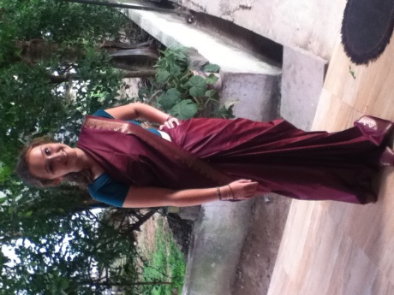
On 12th January 2015 I arrived in Sri Lanka to start my three month volunteer programme with an organisation called SLV Graduate and Student Work Placements. This was as part of my gap year before I start Cardiff University in September to do a Psychology with Professional Placement course. My appointment in Sri Lanka was a Graduate Mental Health Placement and I hoped to gain practical experience working with people with a variety of mental health conditions. I also wanted to experience this in a new culture and to learn from the local professionals I worked with and also from other people on the placement who had a huge range of different experiences in psychology.
SLV was founded in 2010 by a recently graduated psychology student from Manchester; Lucy Nitingale and a Sri Lankan youth worker; Yasintha Rathnayake. It began as a few university graduates from the UK going to Sri Lanka to share their skills where they and SLV felt they would have the most benefit and for themselves to gain practical experience in a field of their interest. From there SLV expanded as more people became interested in the placements; there are different types of placements from psychology to special needs to teaching, it has spread over fairly wide area around Colombo with volunteers based in four areas and sometimes spending a couple of hours to travel to projects from their base. In 2012 SLV began working with Samutthana; the Kings College London resource centre for trauma, displacement and mental health in Sri Lanka, started after the 2004 tsunami. The people who worked here ran workshops for us to teach us more about mental health and the huge stigma associated with it in Sri Lanka and so helped us to understand the contrast with these attitudes to those we are used to in the UK.
Over the three months I was in the country I worked within the community of Kotte; an area near Colombo in which I was based, in the National Institute of Mental Health (NIMH), in homes and facilities for adults and children with special needs and in schools teaching English to primary school children and older teenagers. I lived with a local family and learned much about their culture and traditions through interaction with the people I worked with and also through those I met in the community, and the family I lived with.
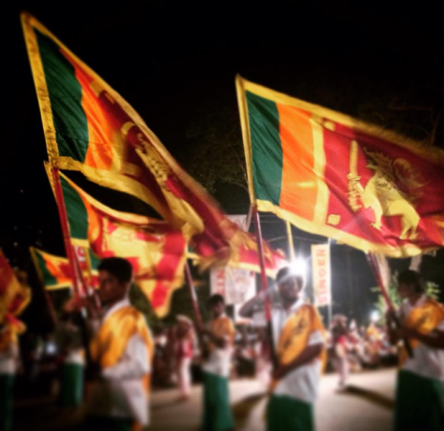
On arrival in the country we were taken to our homestays; a local families house in which we would be living alongside them for the next few months. I was in a homestay with five other volunteers living with a couple and their adult daughter; they also had two older sons although we never met either of them as they both moved to the UK a few years ago. This was such an eye opening and amazing experience for me to actually see how a normal family lives in a completely different culture to my own and to have the chance to learn about Sri Lankan culture from locals. They taught us some of their language, Sinhala, wrote our names for us in the beautifully artistic lettering, helped to explain differences in their culture that we may not be used to; such as showing us how to eat with our hands, introduced us to all the spices and flavours of the island and taught us about their national holiday. An example is Poya Day which occurs every month at the full moon to mark the death of Buddha, on which people throw celebrations with their families and there are huge parades in all the major cities in the country, such as Colombo and Kandy. Our family took us to see the parade in Colombo on our first Poya Day; it was magnificent. It lasted three hours and was filled with traditional dancers, important members of state, men breathing fire and fifty elephants with their trainers, or mahouts to give the traditional name, parading through the streets of the city. The families we lived with helped to make our transition to living in an alien culture much easier, it was clear that they really loved having us there and this helped to make us feel at home, especially as on our first day we were told to address them as ‘amma and tata’ (mum and dad) and they always referred to us as their sons or daughters. It was a really amazing way of getting to know the people there and to learn about this different way of life and is definitely not an experience I will forget.
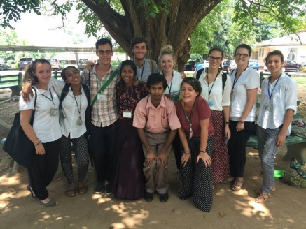
During the week I worked at seven different projects; two special needs, three teaching, one at a Halfway Home and one at the psychiatric hospital NIMH. This is the only entirely psychiatric facility in the country and has approximately 800-900 patients, although the actual number changed every time I was there due to the constant admittances and discharges of such a large hospital. We worked in a huge range of wards; on four different men’s wards, the learning disabilities unit (LDU), women’s geriatrics, occupational therapy units and women’s forensics, for women who are awaiting trial. Generally the people on these wards were really keen to get involved in whatever activity we had planned for them and seemed excited to have new people to talk to. Many had enough English to enable us to hold conversations with them which were really fascinating to listen to them, especially as some of them told us why they had been admitted to NIMH in the first place, and I felt that sometimes all they really wanted was to be able to talk and have someone listen to them in a completely non-judgemental manner and I hope we were able to give them that. As well as interacting with the patients we were also able to talk to the nurses on the wards, especially those on the men’s wards and LDU as they were really enthusiastic and interacted really well with the patients; something we had been told might be quite rare in a country with so much prejudice against mental health. It was really good when the nurses joined in with our games and activities and when we got to talk to them about their experiences working at NIMH and to hear something so positive shows that attitudes in Sri Lanka are changing and that there will be positive impacts at places such as NIMH in the future.
One of the most inspirational people I met at NIMH was a man called Jegath. He was a former patient who had been treated at NIMH for depression and is now an art therapist at the hospital. He used art as a way to express his feelings and so helped him to recover from his depression and become part of his treatment. He now has a small room in the occupational therapy unit which he uses for his artwork, where many other patients come to see him and he uses art and creativity to try to help them the way it helped him. He’s very keen to talk to SLV volunteers and to tell us about his life and his work which is really beautiful, many of which represents parts of his life and his depression. His story is so inspirational and the fact that he’s stayed at NIMH after his discharge to help others like him through their treatment is something I find truly remarkable.
Once a week I also worked at a Halfway Home for women who had been discharged from NIMH but have no home to go to as they have no family or, more commonly, their family refuses to take them in. Sri Lankan law dictates that men can discharge themselves from homes such as these but that women cannot and so are not able to leave unless someone comes to discharge them. Therefore many of the women in this home have been there for most of their lives and the newest patient has been there for five years as there hasn’t been a more recent admission. This was the project that I felt we made the most difference as these women have very little variety in their lives and few visitors which is displayed by the enthusiasm with which they greeted us and by the fact we had the majority of the patients on the wards joining in every session. There are twelve wards and an occupational therapy unit; the wards are divided according to the severity of the conditions; two rehab wards for those most mentally able, two intermediate wards and two acute wards where the women with the most severe mental conditions lived. There is a huge range in mental ability here and I felt it was the project that showed the most severe mental issues; these women arrive at the home with mental illnesses and then spend, in some cases the rest of their lives, surrounded by others with similar or more severe conditions and so their own will worsen over the years. There also appears to be little in the form of treatment given to these women aside from medication and so the home has an air of having given up on the patients there, which is another reason I feel SLV has made and will continue to make a huge difference here more than anywhere else. A lot of the women here have families and loved to talk to us about them or draw us pictures of their homes and their loved ones. They were really keen on various craft activities such as card making, painting and making dough models and loved to do the activities with us and to show off their creations.
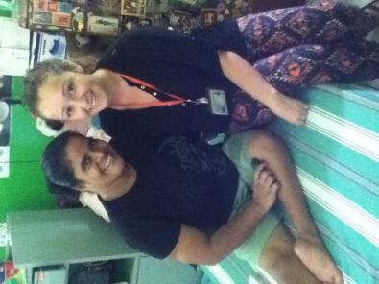
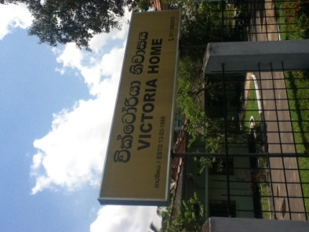
My two special needs projects were very different; the first one was in a home for adults with both physical and mental difficulties, called Victoria Home. It was split in two sections; one for men and one for women and we were only allowed to work with patients of the same gender. The women’s side was split into six wards and in a similar way to Halfway Home is divided according to severity of conditions. On the rehab and intermediate wards the women were able to interact easily with us and take part in the crafts and games we did with them, some of them also had a fairly good level of English and it was fascinating to talk to them and hear about their families and interests. Many of them were really creative and made pillowcases, cards and knitted lace to sell to volunteers and other visitors to the hospital; they were really beautiful and the women were always happy to show us how to make them and amused when my attempts failed. The acute wards were at times quite difficult to work on as the women were bed bound due to their severe physical problems, and were generally fairly unresponsive; either due to their state of mind or the medication they were on, and so limited the activities we could do with them to sensory objects, sights and sounds. It was hard for me to see and quite a culture shock to see people stuck in their beds all day without perhaps the level of attention that we would expect in a UK facility, however it was also one of the most rewarding when we did get a response and I really feel like that was one of the wards on which we were the most help to the people there.
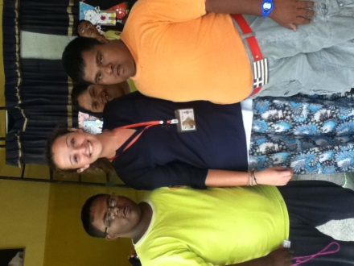
My other special needs project was a dance school called Thidora; the Theatre Institute for Disability Orientated Research and Advocacy. It was a day centre for adults and children with autism, downs syndrome and cerebral palsy where they are encouraged to express themselves and helped to work together in musical and dance performances which they perform in competitions. There were a variety of ages and severity of conditions but it was clear how close everyone there was and how they looked out for each other and all worked well together as a group; an especially difficult thing to accomplish in a group of such varying abilities and needs. They were very enthusiastic and loved our sessions there in which we engaged them in both active games and competitions and more relaxed arts and crafts projects. The woman who ran it was a truly amazing person; she was dedicated to helping them and treated them with the respect that unfortunately is rarely shown to people with mental health and special needs disorders in Sri Lanka due to the huge stigma against those with these conditions. She was a huge inspiration for me and I feel really lucky to have been able to meet her and to have been a part of the project she was running.
On the psychology placement, SLV includes three teaching projects a week for us to give us a more varied timetable and to enable us to help the wider community through its children. I taught English to one primary school class of about 35 children aged 7-8. This was harder than I’d expected it to be as it was very basic English such as the alphabet and basic vocabulary, and the children didn’t yet have enough English to be able to properly understand all of our instructions. They were the most difficult class to control but it was really rewarding when they learned something; one of my favourite memories was when a little girl who had almost no English at all and was really struggling with numbers came up to me at the end of one lesson and recited the numbers 1-10; it’s such an amazing feeling when you realise you’ve actually helped someone even if it’s in such a small and seemingly insignificant way.
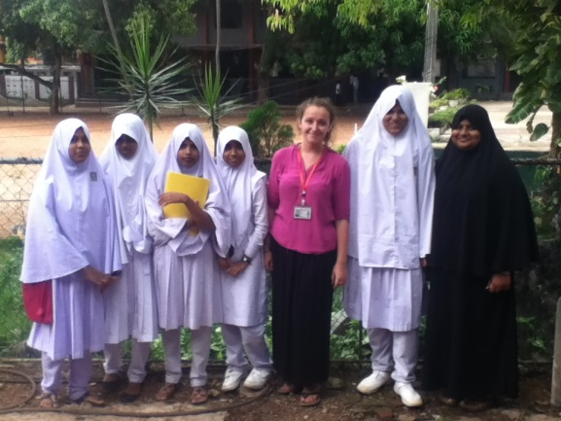
My other two classes were both teenagers in after school sessions at Muslim schools. They were fairly small classes and the level of English was already very good so our focus was on teaching them grammar, sentence structure and in some cases interview skills to help them when they apply for jobs. Both of these projects were really worthwhile as the pupils knew the value of being able to speak English in Sri Lanka and understood that it would benefit them in later life and would probably help enable them to succeed in the careers they wanted; medicine, dentistry, teaching and engineering to name a few. They were really eager to learn but at the same time were so keen to get to know us and were really lovely to talk to; this made it much easier for me as teaching was the one thing I had been really nervous about having never done it before but I found that having a good class really helps! This was also a valuable experience for me as it has given me more confidence in working with children and teenagers but I also felt that we were really helping the students in these schools as they really want to learn the language and as they already have a very good level of English we can help them to improve upon that and so hopefully help them to fulfil their dream jobs in the future.
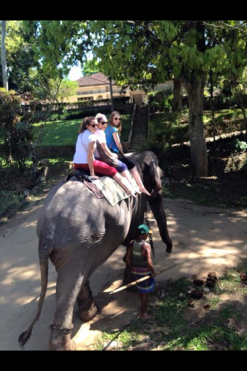
Apart from projects, SLV arranged a few field trips for us during our placements, allowing us to see a different type of mental health facility; such as a Detention Centre for children who have committed crimes, an addiction clinic with a psychiatrist and an opportunity to shadow this psychiatrist, Dr Jegan, for a day. Being able to watch how he interacted with his patients was so interesting to see as was the variety of issues he was treating people for. Due to the stigma or lack of resources many of his patients either can’t or won’t go to the hospital to receive treatment so twice a week he runs Outreach Clinics in temples and churches where his patients can go to somewhere comforting and familiar in their local community to see him. I have so much respect for Dr Jegan as this is not part of his job description and he doesn’t get paid any more to run these extra clinics; he uses his free time to go to his patients to try to ensure more of them continue their treatment and so to help more people. His dedication to his work and his beliefs is really incredible and I feel is something that maybe lacks a little in much of the world.
While we were at projects for five days a week, we had the weekends free to travel around Sri Lanka and see the country. As I was there for 12 weeks I was lucky enough to see so many places and found that it’s a really amazing and beautiful country, as many of the locals will proudly tell you. I visited gorgeous sandy beaches along the south coast where memorials and museums have been erected to mark the 2004 tsunami that devastated much of the south coast and ruined so many lives. I also travelled to the traditional city of Kandy; home to the temple containing the relic of Buddha’s tooth, took a scenic train ride back from Ella in the hill country, went to an evening ‘pooja’ with the locals at a temple in Kataragama; the most religious town in the country, spent a night in the historic old Dutch settlement of Galle and went on an elephant ride in Yala National Park.
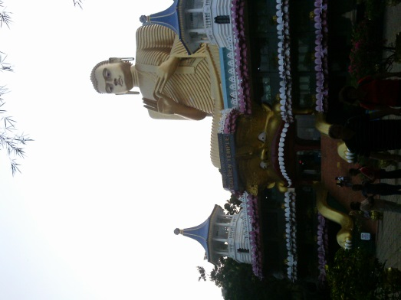
It was all amazing and each place we visited was a remarkable experience with a huge contrast to anywhere I’ve been in the UK, but my two favourite sites were Adam’s Peak and the Cultural Triangle. Adam’s Peak is a pilgrimage site in the south of the country; a mountain of 5,200 steps up with a temple at the top. At the top is an outline of a footprint for which different faiths have different explinations; for example Buddhists believe it to be that of Buddha whereas Muslims believe it to be Adam’s footprint (hence the name) where he stood on one foot atop the mountain in penance for his sins. Therefore it is now a pilgrimage for Sri Lankans of both faiths, as well as being a challenge for tourists, and so even though we started our climb at 1am, due to the temperature being too high during the day, there were hundreds of people all around us; some climbing with us and some descending having already climbed up earlier in the night. It was such an achievement and a really good experience undertaking the exhausting climb surrounded by people from all over the country having a faith strong enough to push their body so far no matter their physical condition; something I really admired. The Cultural Triangle is an area of the country in which ancient ruins stand; it was originally known as the ‘Kings Land’ and is the site of the earliest Sinhalese civilisation. It was fascinating to visit the ruins of the ancient city of Polonnaruwa, last inhabited around the 12th Century, and see the old palaces and temples and the huge Buddha statues still carved into rock faces. We also visited the Dambulla Cave Temples, five caves filled with statutes of Buddha and wall paintings depicting Buddha’s image and his teachings, signposted by an enormous golden Buddha above the entrance to the caves. The last thing we did in the Cultural Triangle was to climb Sigiryia Rock; an imposing 200m high rock set in the ruins of an ancient town which surrounded the rock when King Kassapa constructed his residence atop the rock in the 5th Century. Sigiryia means ‘Lions Rock’ as this king had carved the top of the rock into the shape of a lion; only two paws of which still remain today. It was another difficult climb but definitely worth it once we saw the views and explored the ruins at the top. It was really amazing to be able to see so much of the country and to experience its history; both ancient and modern, and to see and meet people from all over Sri Lanka rather than just the relatively small area in which I was based.
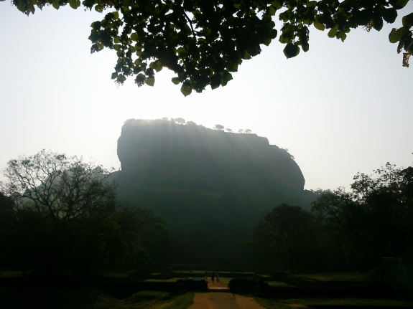
My trip to Sri Lanka was a completely unforgettable experience and something that I know I will never regret. It allowed me to experience a completely new culture, not as a visitor would, but as a real resident does as in the whole time I was there not once did I really feel like a tourist, which I feel is a really rare experience and something I am unlikely to have many times again. It enabled me to pursue my interest in mental health with real experience that I would never have been able to get in the UK at my age and with the skill level I already had. It helped me to develop those skills as I worked with a huge variety of people of different ages with much more severe conditions than I have ever experienced and taught me some new skills, such as the patience and organisation it takes to teach a class, not to mention the confidence it takes to get up in front of a class of thirty students and teach them something completely new. I made some great friends while I was out there both among the other volunteers and with the local people I worked with and got to know in the country and I have met some truly inspirational people who I will never forget and who have definitely inspired me to pursue my career in mental health.
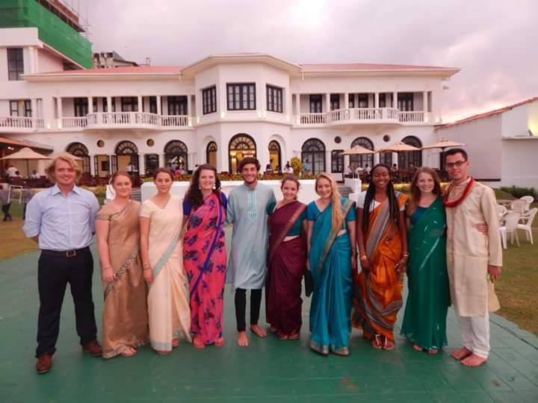
It was a really valuable experience for me but I also hope I managed to make a difference, however small, to the people who I worked with at the projects and I feel honoured to have been a part of some amazing organisations that make such a positive impact on people’s lives and strive to improve the psychiatric system in Sri Lanka.

