Making a Difference in Tanzania
(And the difference Tanzania made to me!)
By Mark Loveless
At the end of January 2014 I went out with a group of 14 volunteers to Musoma, Tanzania, to work with a charity called Go MAD (Go Make A Difference). We lived there for 5 months and in that time achieved more than we could have imagined, building up some really great relationships with the local people – some from scratch and some building upon those that Go MAD has created over the past 7 years. Whilst all us volunteers stayed in one house together, we spent most of our days with the locals which enabled us to establish these relationships. I worked in a sub-team of 7 volunteers as co-leader, working in a rural village just outside Musoma called Kyamajoje. Here we worked on our two main projects: the construction of a health centre and the construction of a pit latrine toilet for a man named Mtani.
Mtani is just over 20 years old and became paralysed from the waist down a few years ago after falling out of a coconut tree and is looked after by his Grandma, a subsistence farmer, as he has no parents. When I first met him I was blown away by how happy he was despite his situation, and by his unbelievably wide smile! He is absolutely adored by his local friends and family and is at no point without visitors or with many children hanging off him and his bike! (He was bought a hand-pedalled, 3-wheeled bike previously by Go MAD which enables him to get around – it was made by Lake Victoria Disability Centre in Musoma which trains and employs people with disabilities (who would ordinarily struggle to find jobs) in metalwork.) He was always so happy to see us and we him, and we’d always be able to have a good laugh despite the language barrier/our limited Swahili. Some of the girls on our team also started to help him learn English, though we’d all chip in whilst we worked! Learning on the job, we carried out the entire construction of the toilet ourselves, from concreting the foundations to bricklaying to making the roof trusses, and painted a mural on the side at Mtani’s request. We designed it so that it would be as accessible as possible for him; a sit-on toilet on one side and a wash area on the other with space in between to enter, turn around and exit in his wheelchair. Wooden beams will be installed above both the toilet and wash area so that he can pull himself up out of his wheelchair and swing into the section he wishes to use - we just ran out of time on this project so did not fully complete it but it should be finished very soon.
The majority of our time however was spent at the Health Centre just around the corner from Mtani’s house. Go MAD has been asked to build this by the Diocese of Mara as the need for it is very great. When completed it will be staffed and equipped by the Government and hopefully provide health care to around 10,000 people. When we arrived in January most of the foundations had been built by a previous team and, carrying on from what they started, we concreted the floors, ramp and verandas, organised the construction and rendering of the walls, built and installed the roof trusses, organised the completion of the roof and created a mural in celebration of the community’s achievements. As we had to mix concrete by hand a lot of our time was spent doing that, which meant that we spent a lot of time with our local workers who helped us and who by the end became our friends. Throughout my time I was taken aback by the hospitality of these people, our friendship with whom was mostly based around actions rather than words. I learnt a huge amount from this, the fact that we could develop such good friendships using just basic verbal communication meant that the relationships we did build were very raw and very real. In this way they were different to any kind of friendship that I had experienced before, and by getting to know them initially through their actions rather than their words, I learnt to really love the people of Tanzania! They are such a hospitable people and so filled with generosity not just toward us, but toward their own local community as well – everyone is family to them. For example, on our last day we held a celebration in Kyamajoje to say thank you and congratulate the community on all the work they had achieved in constructing the Health Centre so far. They brought hundreds of chairs, tables, school desks, tarpaulin for shade, the Bishop provided music and prior to the day the community had also cleared a large area around the Health Centre from weeds and building debris – all for free and all out of sheer generosity! Throughout the trip this was a recurring theme; we received far more than we could give, particularly in what we learnt from the African people.
Our greatest friend in Tanzania and possibly my best example of the generosity that we encountered was Tabu, a single mother living with her six children in a tiny, two-room mud hut. She would often come out to Kyamajoje with us for work. She helped us mix concrete as she is incredibly strong (and has been seen carrying a 50kg cement bag on her head!) which is how our relationship initially started. She began to invite us round for meals: round for lunch, round for chai, mandazi, peanuts, round for chapattis before we went off to work in the morning… her generosity knew no bounds! Whilst we would buy the food required for lunch she would always add something extra of her own for us, and at one point gave my friend Emma a kanga as a gift! Generosity in abundance, and yet she struggles to pay her rent every week. (We are planning to buy her some land by the end of this month in the hope that we can raise enough money to build her a house so that she won’t have to pay rent. This will mean that she can use her income to pay for her children to go to secondary school, and will also enable Go MAD to build her a water tank if we are able to raise money for that as well.) We got to know her children really well, again mostly without speech, and would spend hours at her house playing with them, chasing them, tickling them and messing about. Whilst visiting her on our last day one of her sons, Niko, saw me in the distance and ran from their house to jump into my arms. The joy that I experienced from knowing this child and his family was again a recurring theme from my time in Tanzania – the people really know how to be joyful! Perhaps it’s because they have so little that it’s the only thing they have left. Either way, it had a profound effect on me and highlighted to me some of the many issues of our society back in the UK.
On the subject of joy, my favourite day in the week was Sunday when we would go to a local village church. Here the community would gather to sing and dance for God with each other and us, with such a huge amount of joy and energy it was infectious! I have never danced that hard in my life… After church we would run a sports afternoon for the local kids and hold football matches. Again not much was said verbally, but the sense of community we felt playing with them and the friendships we built was something special. I’ve avoided mentioning this until now as it has become almost a cliché of people returning from Africa, but the country really does have a sense of community that is so different from the UK, and so lacking here at times. It is this I think that makes the biggest impact on people who go out to live there from a Western society, the sense of acceptance, hospitality and love. To put it simply, the people teach you so much about people!
I would like to say a massive thank you to all the members of GIFT for supporting me in my trip and helping to make it possible. I am so thankful for your generosity and for the opportunity I had, I can honestly say it was probably the best 5 months of my life so far, and I learnt a huge amount from the experience.
Thank you!
Mark
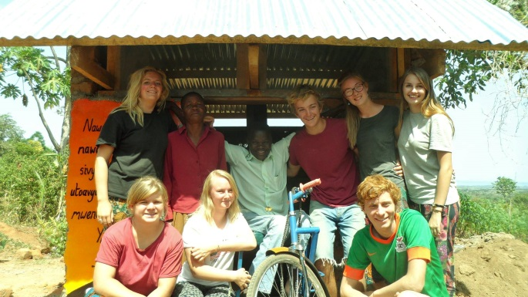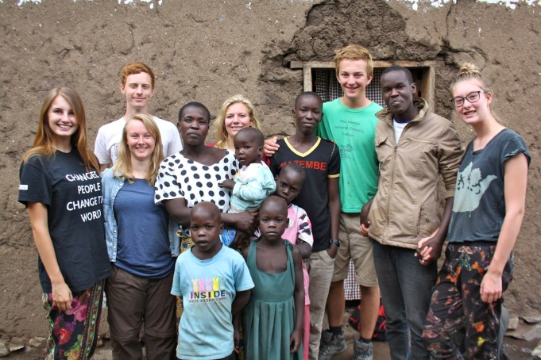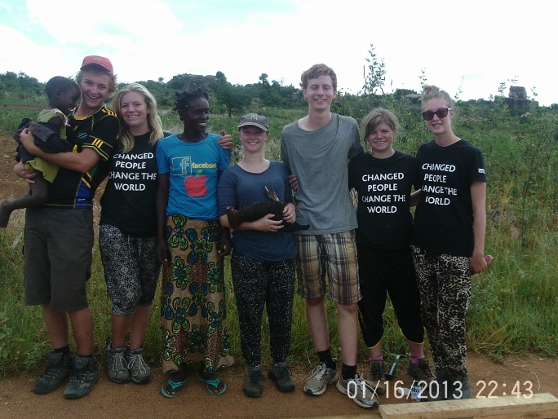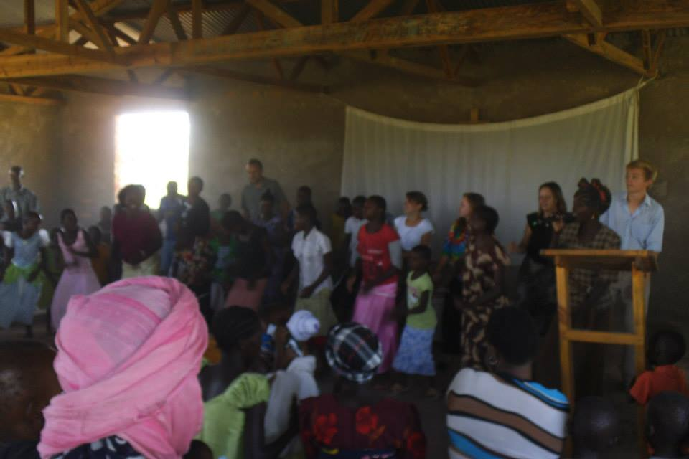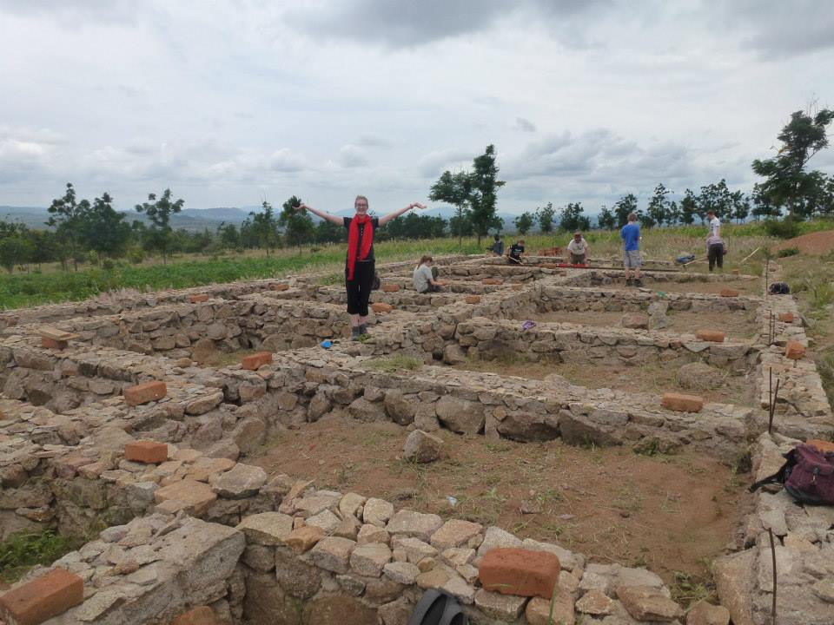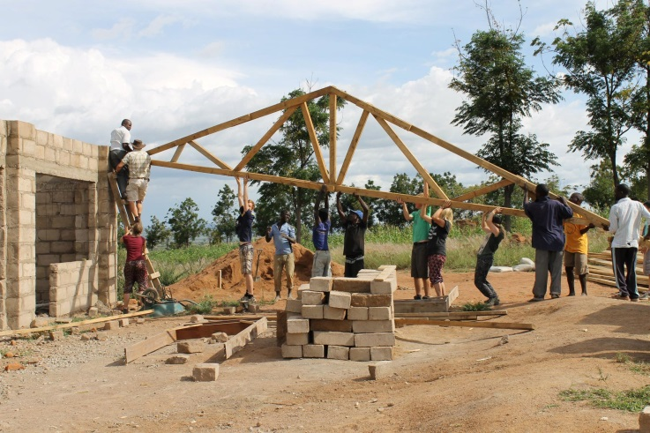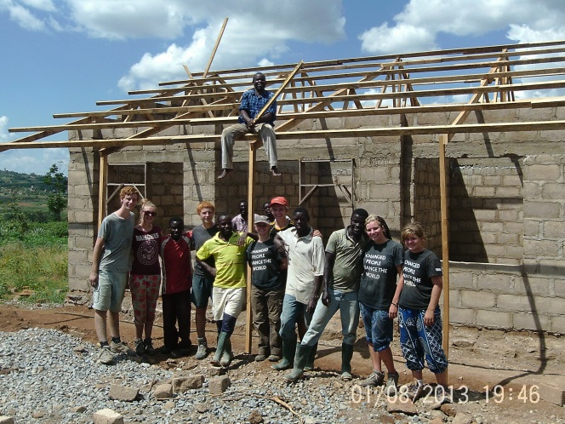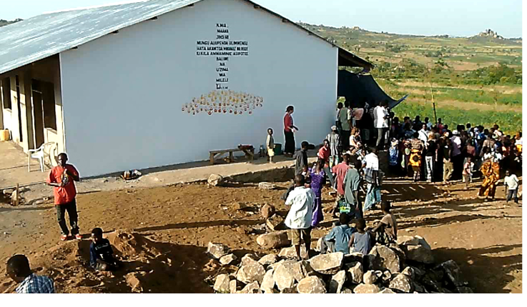
With Mtani and his completed toilet!
With Tabu and her family at her house
With Fairy and her Mum after they gave us a hen
Dancing with the choir at Mikiringo Church
The Health Centre – where it started and where it is now!
Mark

