Robert Buck Uttarakhand, India- GIFT Report

This summer I spent a very enjoyable and fruitful 6 weeks volunteering with the Central Himalayan Environment Association (CHEA), an Indian NGO. CHEA was setup in 1981 as an independent not-for-profit organisation committed to the sustainable development of the Central Himalayan region. CHEA’s work is divided into the four thematic groups of: Climate Change; Research and Documentation; Art, Culture and Handicrafts; and Rural Livelihood Initiatives. The majority of my time with CHEA was spent working at their central office in the town of Nainital, Uttarakhand state, northern India. However I also participated in a number of field visits to CHEA’s project sites.

My time in India working with CHEA was a unique and hugely valuable opportunity to experience the local culture of Uttarakhand. Simply working in CHEA’s office provided a useful insight into the culture of Indian NGO work and over the course of my internship I developed good working relationships with my fellow CHEA colleagues. Indeed the Chief Executive of CHEA invited me to his home for dinner a number of times, it was very interesting to hear his views on India’s current affairs and political situation. In particular India’s Independence Day on August 15th gave me a great chance to reflect with my colleagues on the history of India since it’s Independence and India’s status as the world’s largest democracy. I learnt that although Indian people are generally very proud of their Independence, most people are also very grateful for the legacies provided by the British Empire’s colonial rule. This surprised me, since I have frequently studied in my University Geography course about the terrible consequences of imperial rule. Yet while Indian people acknowledge some of the atrocities committed under colonial rule, they view the education and transportation systems provided by the British in a very favourable light. This was especially true for the town of Nainital where I was living for most of internship, as this was a hill station established by the British. When speaking to shopkeepers, after they found out I was British, many of them would be very friendly towards me and often say how great a country England was. Therefore this element of my interaction with local people in Nainital was especially enlightening.

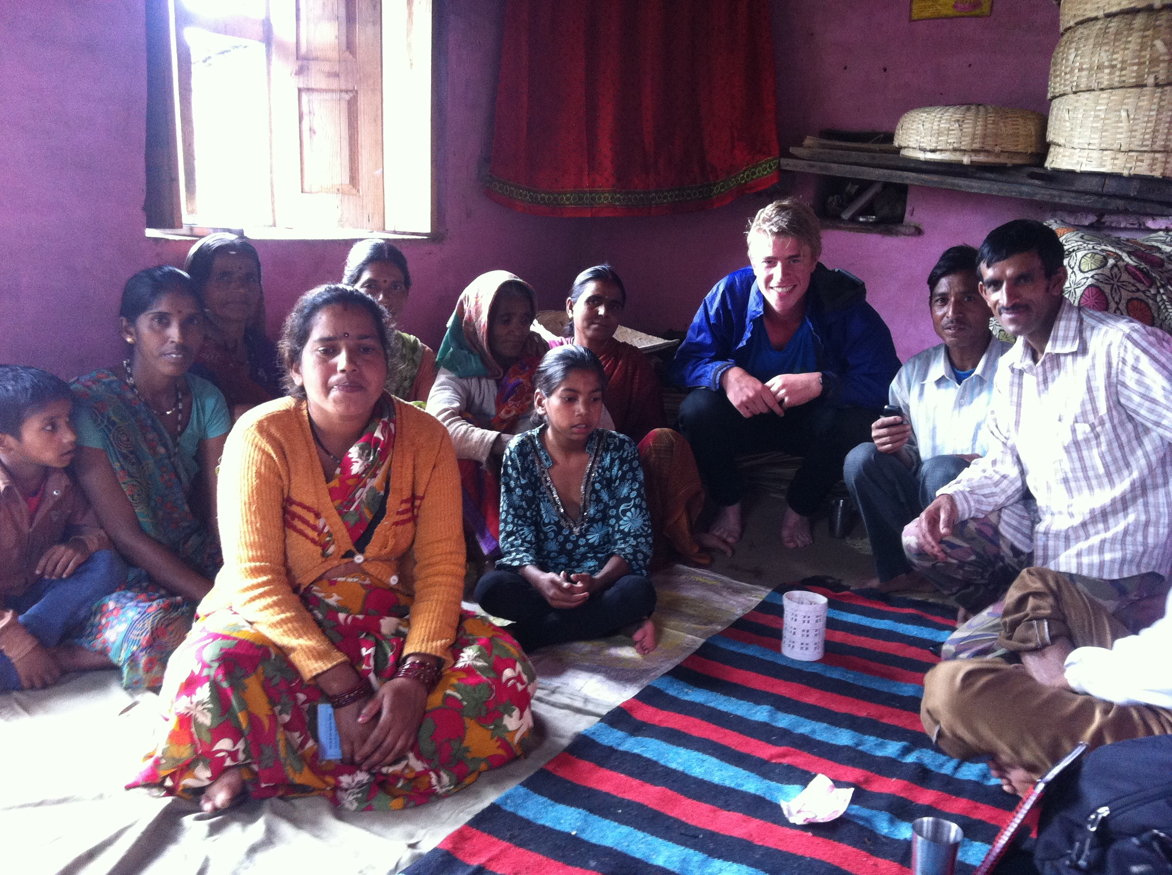
As part of my work for CHEA I carried out a research project exploring the out-migration of young men from rural village communities in this mountain state. With a CHEA translator I visited remote rural villages where CHEA’s development projects have been implemented in order to run focus group discussions with the local people. This provided me with an amazing insight into a completely different way of life. Speaking to groups of men and women I understood how their life primarily revolves around the livelihood labour required to collect water, harvest fodder, cultivate crops etc. Whilst it is a very tough life physically and they have no luxuries or local facilities, such as Internet access, all the people I spoke to were very happy. Thus this emphasised to me the importance of a simple life that revolves around close contact with one’s family and the natural world.

Aside from this, for three weeks of my time in India I stayed on with a local family. My homestay was with the family of a colleague from the office and this was definitely one of the highlights of my trip. My host, Anil Kanwal, lived in a rural village community called Khurpatal located approximately 10km from the office. Staying with his family for 2 weeks provided a fascinating and enjoyable insight into the lives of the local people. I was lucky enough to be there at the time of a Hindu festival unique to Uttarakhand state, celebrating the beauty of nature. This meant I got to accompany Anil to the local temple and watched as he went through the different ceremonies. I loved learning from Anil about Hinduism and how it teaches to love all aspects of nature. For example even though monkeys are problematic agricultural pests, people never harm them since people believe certain gods take the form of the monkey.

Anil’s family was very generous and welcoming, always providing me with delicious local food. This included vegetables grown by the women of the family (Anil’s wife and mother) in their nearby food. I soon found out that in Uttarakhand agricultural labour is completed solely by the women of the household, men only do the ploughing of the land with the buffalo. Moreover the order of eating in the household was quite a surprise. Rather than eating dinner together, traditionally first the heads of the house would eat (the father and grandfather) and the wife, who cooks everything, is only allowed to eat herself once everyone else has been fed. Adapting to the local way of eating by simply using your right hand was at first quite a challenge, but I now think I’ll find eating with a knife and fork very strange! I was served typical north Indian food, consisting primarily of dal and chappatis (or ‘roti’ as they are called in the region). Local people’s diets were mainly vegetarian with meat often only eaten a few times a month, and meat was restricted to chicken and goat. Pork remains quite rarely eaten in the area and of course beef is forbidden under Hinduism. Learning about Indian cuisine highlighted to me the diversity of India as a nation. India is a huge country and so food varies greatly between states, with South Indian food having a very distinctive style compared to the heavier cuisine of the northern states, for example chappatis are the main carbohydrate eaten in the north whilst rice is much more popular in the south.

My host family also spoke to me about the changing cultural norms of India. Whilst Anil’s family still maintain the traditional Indian family structure of a wife and husband living with the husband’s parents, increasingly in metropolitan areas families are adopting more of the nuclear family structure that we have in Europe and America. Additionally, the nature of arranged marriages is changing with women being given greater freedom to choose their partners. People are also generally marrying later in life in India. For example, Anil’s mother married her husband when she was just 14 years old yet now it is more common for women to marry between 25 and 30 years old.

Perhaps the most unique aspect of my homestay was the fact that I attended a Hindu funeral. Very sadly at the end of my time there the grandfather died of a heart attack. Attending his Hindu funeral was an experience I’ll never forget. In Hinduism there is a very specific set of mourning rituals once a family member passes away. All male close relatives of the deceased grandfather shaved their heads as a sign of purity and respect. The entire local village, all family and friends gathered at his house the morning he died. It was very touching to see how quickly all those who knew the grandfather responded to the news of his death. All the women sat on the floor around his dead body whilst the men including myself stood apart separately. As the men prepared the body for cremation the women said their goodbyes, all the women covered their heads as a sign of respect. Cow urine was sprinkled on the body since the cow is viewed as holy in Hinduism and a red sheet was placed over the body. It was very difficult witnessing the pain and distress of the wife and daughter-in-law of the grandfather, particularly as they had to say goodbye to his body at the house given that under tradition women are not permitted to attend the cremation. The body was subsequently carried away on a bamboo stretcher, with the son dressed in white leading the procession. As the body was carried along all the men chanted, as a way of bringing the soul closer to heaven. The cremation took place by a small mountain stream that would ultimately feed into the Ganges river, with the grandfather’s body burnt on a large wooden pyre. I learnt it was a particularly significant funeral since the grandfather is the head of the family, thus with his death his son Anil must now assume the duties of the welfare of the family. This was a very sad and touching experience.

By living with Anil’s family for just 3 weeks I developed a strong bond with them and am very touched by their friendship and generosity. In particular I enjoyed spending time playing with their baby daughter, Anil informed me he wants his daughter to learn English when she’s older. Therefore as a goodbye present I bought the daughter a toy play set that helps you learn the English alphabet, Anil’s family seemed very pleased with this. Having exchanged addresses with Anil I hope to keep in contact with the family for many years to come and witness the progress of their daughter. I even promised to return to stay with them again once I have my own family!
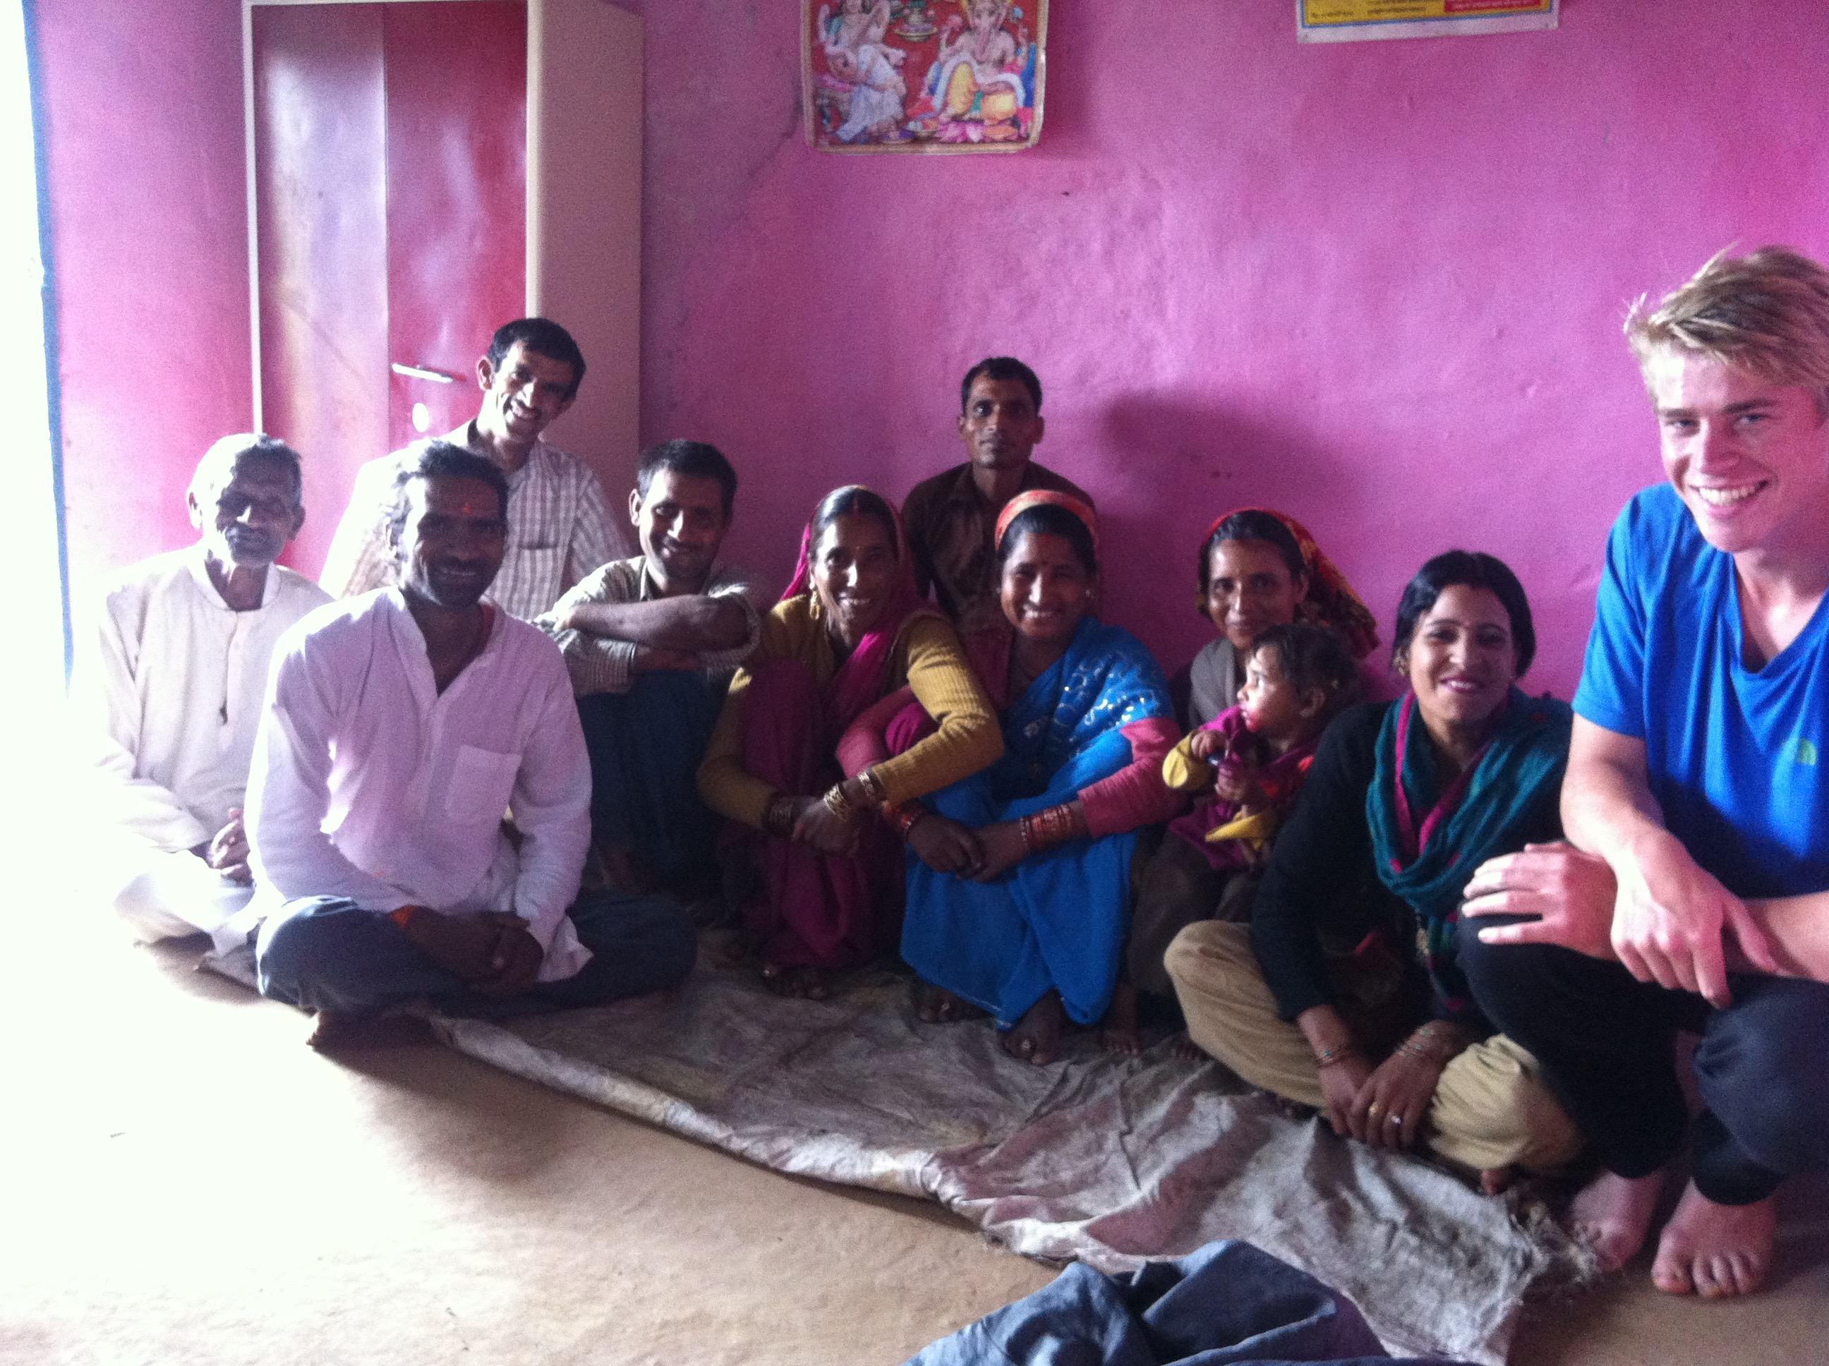
Overall the 6 weeks working for CHEA in India was an immensely beneficial and enlightening experience, in which I developed good friendships with a number of people and truly experienced the local culture. I would like to thank the GIFT Trustees for their generous grant, without which I would not have been able to travel to India for this amazing experience.

