My Experiences in lndia
Rebecca Envine
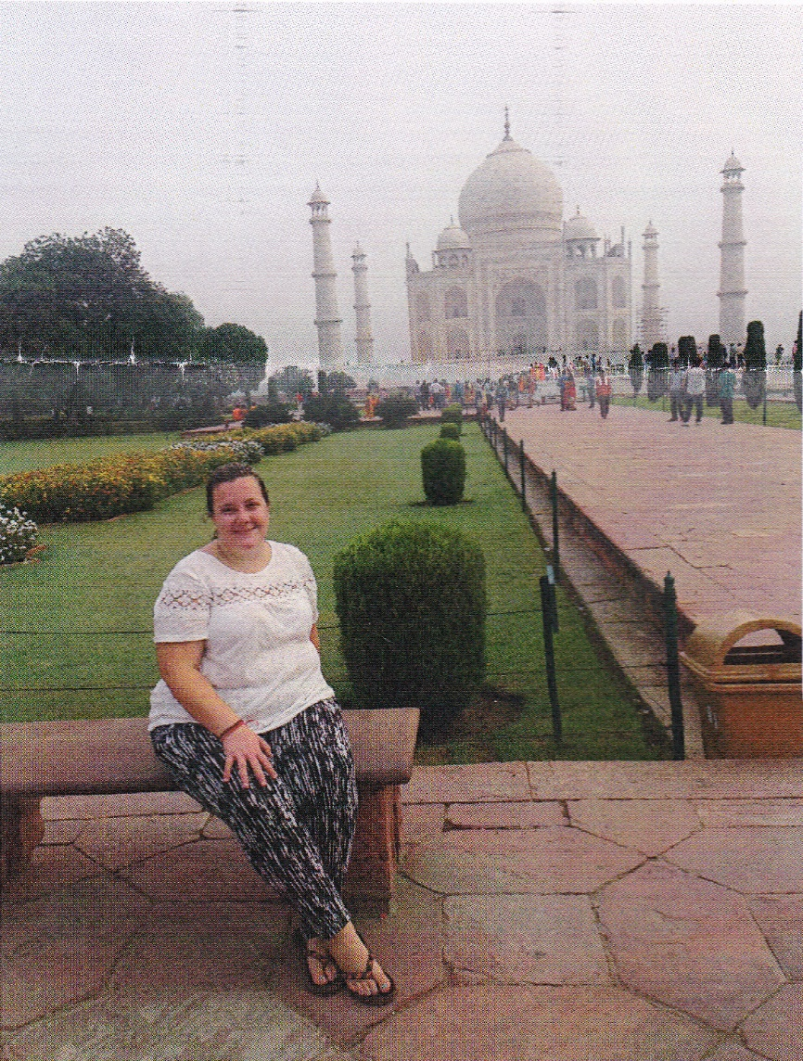
Introduction
I have always been interested in what life is like for people in countries very different to my own decided to visit India as I wanted to find out more about the local culture, whilst also helping local people if possible, and learning about myself.
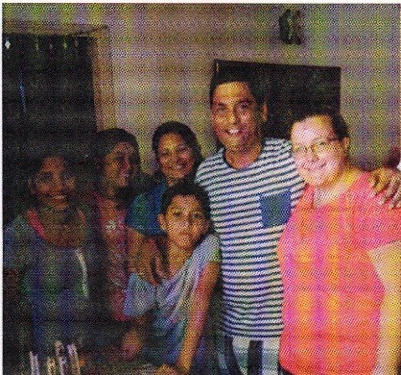
I decided to visit with the volunteering organisation "Plan My Gap Year", and spent 8 weeks living in Faridabad, a city just south of Delhi, with the Bandhu family. I am a medical student, and used this experience as part of my university course, spending my time during the days volunteering at a medical camp in the slums and observing surgeries. I was also able to spend time working on other local volunteer-led projects including a school for disabled children and a project aiming to empower women living in the slums.
Life with my Host Family
For the duration of my trip, I lived with the Bandhu family, comprising of Vishy, an audiologist who runs and coordinates all of the volunteer projects I was involved in, his wife Kranti, and their two children.
They-were all incredibly welcoming, and made me feel at home as soon as I arrived. Living with the family meant l was able to learn about their everyday lives, and even be involved in things such as helping the children with their homework! (Although only the English parts of it of course!).
Living in the house was also Deepali, who was two years younger than me, and responsible for the daily running of the house, including all the cooking and cleaning. She was amazing, and despite having limited English, I learned to communicate with her through broken language and a lot of hand actions!
I was amazed that over such a short space of time I became so close to the family. I was particularly honoured when on my last day, it was Vishy's (the dad of the family) birthday, and because I had to leave early they produced his birthday cake at 7am so that I wouldn't miss out!
Medicine in lndia
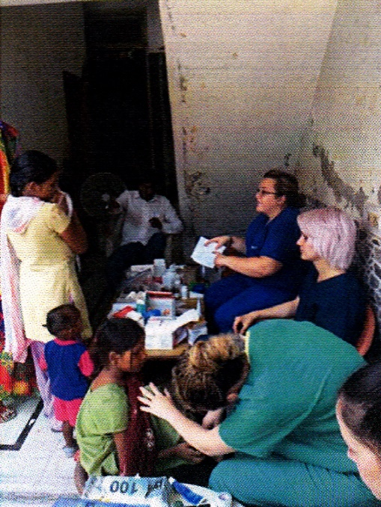
I spent the majority of my mornings in lndia volunteering in a medical camp in the slums of Faridabad. The camp was run from a small courtyard at the entrance to one of the volunteer's houses. lt was about the size of a normal bedroom in the UK, and patients were rotated around three 'stations', which were tables in different corners of the courtyard. The first was where patient histories were taken, the second where observations including blood pressure and blood sugars were taken, and the third where patients were given medications. Each clinic would last 4 hours, during which approximately 80 patients were seen, averaging one patient every 3 minutes - a bit quicker than in the UK! The camp had many challenges - working with a translator was difficult, as was accepting the limits of what we could to for our patients with the limited resources available.
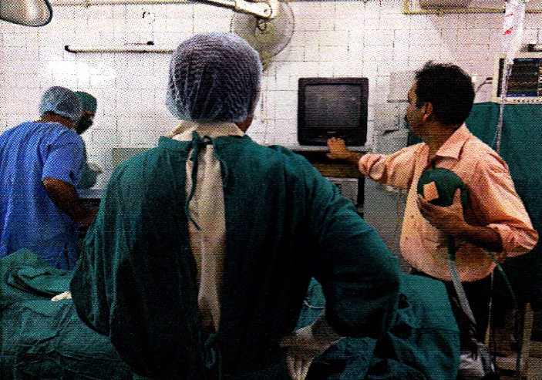
I often found myself thinking "at home, we'd do this..." Cases I saw ranged from simple joint pain to children seriously ill due to vomiting and diarrhoea. Over the 8 weeks I spent in the camp I saw many shocking things; horrific burns, infected wounds on the legs of children whose parents could not afford to take them to the doctor, a man brought me his x-ray which he had paid to have taken and showed he had a hip fracture, yet he could not afford treatment in hospital. An 8 year old girl who came to the camp every day to pick up medication for her sick father who could not leave their home. I met a mother who brought in blood test results that revealed her three year old had typhoid.
Another shocking aspect of my elective was observing surgeries, which were carried out in dirty rooms, and on two occasions I saw a rat run across the floor. Instruments were re-used having been 'sterilised' by being put in warm water and then wiped off on the surgeons' gown. Yet in the area I was in, with people living in extreme poverty, this was the best care they had access to.
And as shocking as this was, I soon recognised that despite its flaws, the doctors were doing the best they could-with limited resources, and ultimately saving lives'
My experiences of healthcare in lndia made me realise how lucky we are to live in a country where healthcare is freely available, so no one has to watch their child die of a preventable illness, or go hungry to pay for medications. I learned a huge amount, not just medical knowledge, but also about a culture so different to my own. I feel so lucky to have been able to have had this incredible opportunity to visit such an amazing country, whilst increasing my medical knowledge, helping a community that so desperately needs it, and making myself a more compassionate and understanding future doctor.
Traveling Within lndia
As the projects I was working on did not run at the weekends, I was able to use these to travel to different places in lndia. I most often travelled by train, many of which were overnight and not the most comfortable, but they were very cheap compared to the cost of trains in the UK! I was able to visit several places in Rajasthan, the region closest to Delhi. This included visiting Jaipur where I rode elephants and visited the amazing Amber Fort, Agra the home of the Taj Mahal, and Jodhpur where I went on a safari in the desert and rode camels! I was also able to go on a tour where I visited villages near Jodhpur, which were very different from anything I had ever experienced before' These villages were very remote, and despite being less than an hours' drive from a large city' most of the people there had never left the village. lt was here that I learned about life without electricity, and the very traditional lifestyle these people live'
I also travelled north of Delhi, where I visited Amritsar, home of the Golden Temple, which is the largest Sikh temple in the world. This city is very close to the border of lndia with Pakistan' and one night I was able to travel to the border, known as the Wagah Border' where I observed a ceremony where soldiers from each country cross the border. This experience was very surreal, as I was able to see the crowd across the border in Pakistan whilst standing in the crowd in lndia!
I also visited Rishikesh at the foot of the Himalayan mountains, where I was able to paddle in the holy river Ganges, and Daramshala, the home of the Dalai Llama, where many people of Tibet live following its occupation by china. I was enthralled by all the places I visited, and fascinated how such different places with their different cultures and even climates, where I had such different experiences, were all part of the same country'
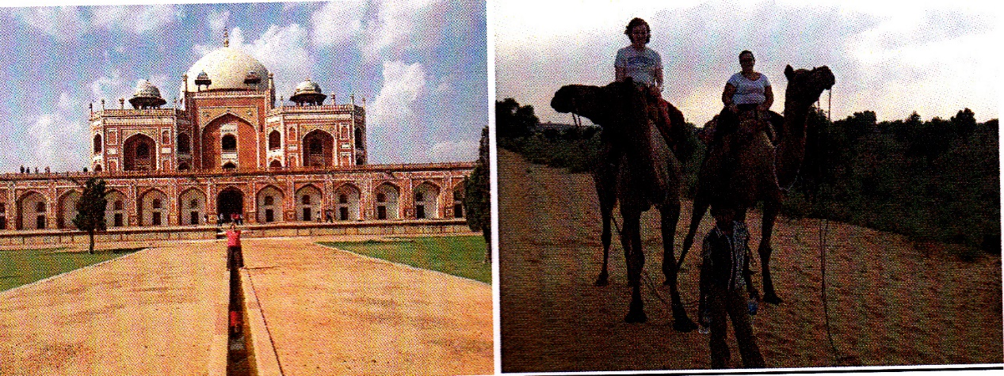

Conclusion
I had an amazing experience in lndia; 6nd learned more in eight' weeks than I thought was possible! This was not-only about the local culture, but also about myself-l believe this experience*has really changed the way I look at the world, and it has taught me to be grateful for what I have;-When previously I may have complained about something such as not being able to afford something, I will remember the people I met and how lucky I am to be in the position I am. I feel honoured to have been welcomed as a member of the Bandhu family, and will definitely never forget their-hospitality -I can't wait to go back and visit again as soon as possible!

