Flora Miles 2015

11 weeks in Kenya with Education Partnerships Africa: my thoughts and experiences

This summer I spent 11 weeks in Kenya, the majority of this time living in the beautiful Western region of Kakamega. This trip far exceeded my hopes and expectations, turning out to be far more enjoyable and rich in formative experiences than I could ever have imagined. I have returned to England with broadened horizons, increased self-confidence, new knowledge and wonderful new friendships.
The bulk of my time in Kenya was spent working in Ematiha Secondary School, a small school in rural Kakamega. I was working together with one project partner, with f 1800 and 9 weeks between us with which to work in partnership with school members and stakeholders in the local community to make improvements to the quality of education in Ematiha. The close nature of this partnership meant that I came to befriend staff and students at the school, who welcomed me into their homes and community and taught me much about their way of life. I worked largely with David Ambani, the principal of Ematiha Secondary School; a fantastic, dedicated man who I feel privileged to know. lt is from conversations with Ambani that I most significantly came to understand the problems faced by rural secondary schools in Kenya, perhaps the most serious issue in Ematiha being a very low rate of fee payment due to the poverty of parents reliant on the ailing sugarcane industry. This was an issue which I had not faced before in England, where secondary education is freely provided by the government. Working in Ematiha gave me a much greater appreciation of education, and a more personal understanding of the difficult situation faced by people of my age in rural Kenya.
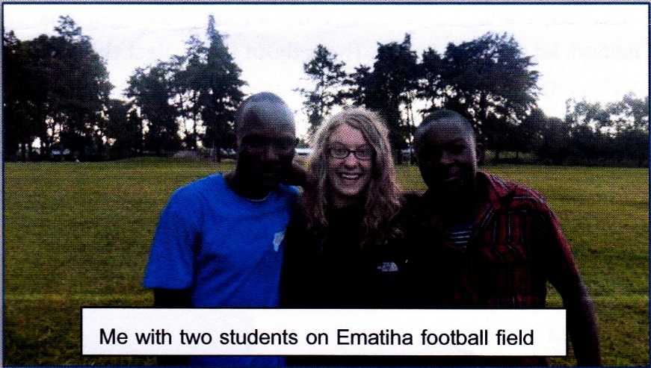
My project partner and l often worked in the school staff room, where we befriended members of staff. One of the friendships which I treasure the most is that which l formed with Lynette Omutiti, a teacher at the school. I found Lynette to be an incredibly kind, open, gentle woman. At times we disagreed in our views towards certain issues: for example, Lynette taught sexual abstinence to her students as an attempt to prevent teenage pregnancies, while my project partner and l, having been raised in England, viewed the use of contraception as a more effective measure. With Lynette, I was able to discuss such issues openly, comparing and contrasting life in our respective cultures. Such conversations were highly enjoyable and educational. When l visited Lynette at her home, she showed me through photo albums, helping to forge what I felt to be a personal connection and valuable friendship, which I hope to maintain.
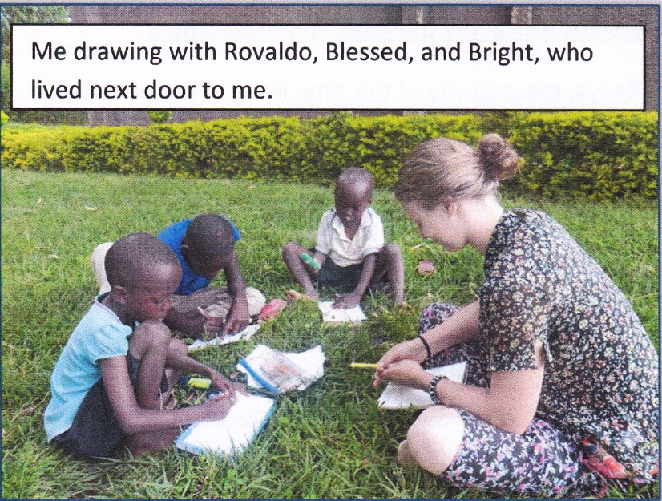
At lunchtimes, I made the habit of eating lunch with the school's students, many of whom are around my own age. We shared conversations while eating ugali, a Kenyan staple food made from maize meal, and when walking to the water pump to wash out our bowls together. One lunchtime the girls painted my fingernails bright pink - a colour which I detested, but an experience which broke down awkwardness and opened out our friendship. Another way in which I made friends with the students was by joining in with their love of football, often played on a nearby field. When spectating, I had a chance to sit with students and talk to them about the differences between England and Kenya. When l joined in with the game, the students were impressed to find that I did not mind being outside in the rain, and I was impressed at their skill! I also got to know some of the younger children from the adjoining primary school, with whom I would often sit and draw pictures. By the time I left Kenya, a wall of the house in which I lived was covered in these pictures, which gave me an insight into the concerns of Kenyan children: skipping rope, cars, cows, houses, and cups all reoccurred frequently!
Although based at the school, my project partner and I spent time in the surrounding village of Ematiha and the relatively nearby town of Kakamega to order resources and contact workers needed to carry out the project. This was a highly educational experience. I suddenly found myself in a position in which I needed to order a water tank from a hardware store, having never done this in England, let alone in Kenya. Throughout the project this caused my confidence to grow dramatically. I arrived in Kakamega at the end of June confused by the seemingly chaotic traffic, clueless as to how to respond to the enthusiastic motorcycle taxi drivers looking for customers, and with no idea how business is conducted in Kenya. Within a few weeks I felt much more comfortable, and by September I was able to navigate the town alone confidently, locating suppliers and enquiring for the services needed. I truly value this experience, which has left me feeling much more able to conduct business upon my return to England and in future trips to East Africa.
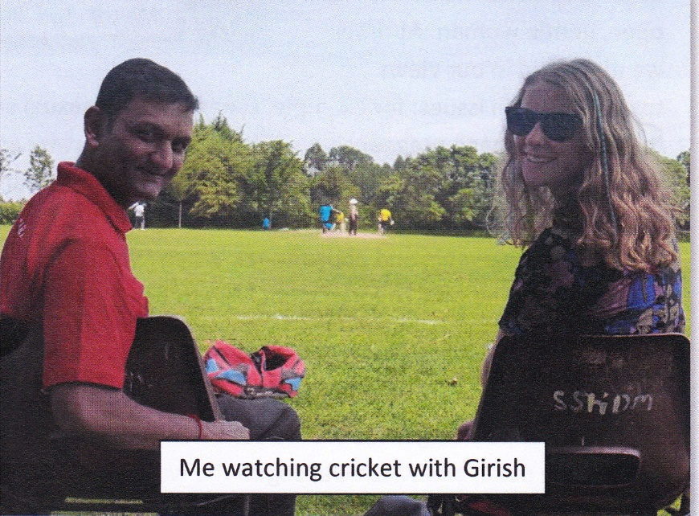
As I became knowledgeable about Kakamega town, I made friendships with suppliers to whom we became regular customers. Girish, a senior worker in hardware chain Mitra Enterprises, became a particularly precious friend. One day he invited my project partner and me to watch his cricket team, and we accepted. This is how we got to know many members of the Kenyan-Indian community, of which Girish is a part, having moved from Gujarat some decades ago. The cricket was very enjoyable, and we were given delicious lndian food, all of the ingredients and cooking methods explained to us by Girish. I learnt about the strong sense of community between Indians in Kakamega, who often all come together for religious events. We continued to come and watch the cricket at weekends, becoming keen supporters of the Mitra team!
I also met great people closer to home, in the rural village of Ematiha itself. One of my closest friends was Christine Akhonya, the wife of the welder who created a water tank stand for the school. We regularly visited Christine's house, developing a friendship in which we could show up uninvited and always be welcomed - a fine example of the relentless and impressive Kenyan friendliness and hospitality! Christine always provided us with excellent food and tea, taking great joy from our gratefulness. As we watched dubbed Latin American soaps, very popular in Kenya, we often talked about family in Kenya and England. Christine was interested in whether extreme relationship problems are as prevalent in England as they appear on TV shows, and I was fascinated by the Kenyan system of marriage. I learnt from these conversations that wives in Kakamega always move to the home of their husbands, leaving their own family, who are paid a dowry by their family-in-law, behind. Christine hinted at how she missed her aunt, with whom she had lived before being married. I took great interest in all this primarily because it was a true example of some of the concepts of kinship about which I have learnt in my Social Anthropology degree. Christine, her family, and lare managing to stay in contact through Facebook and email.
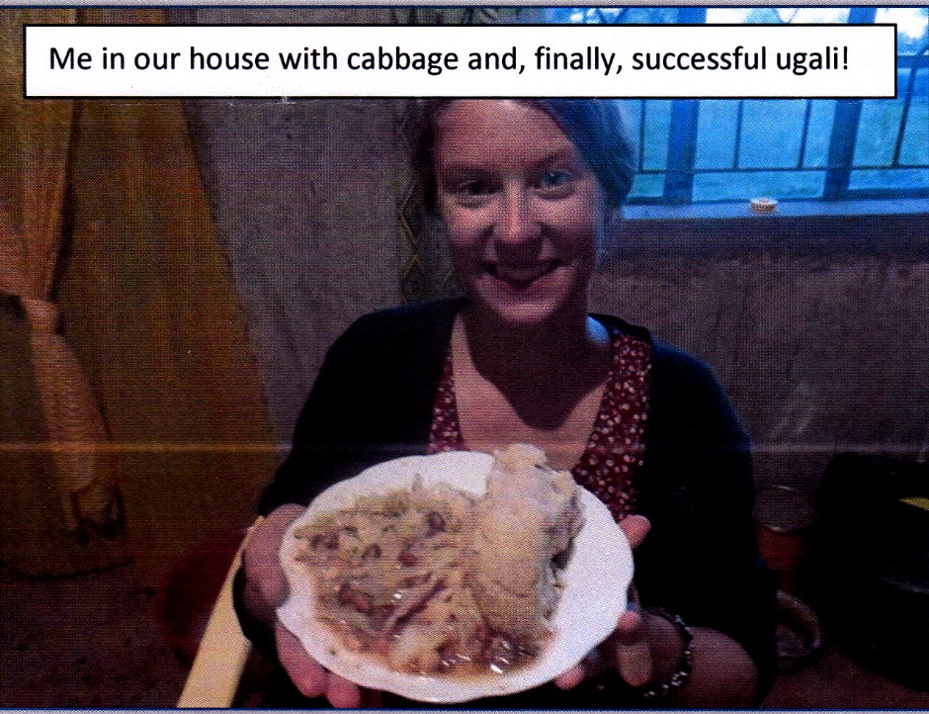
Our accommodation in Ematiha was beautiful but basic, without running water and with a simple gas canister for cooking. I sincerely enjoyed learning how to live with resources much more limited than most homes in England. By the end of the summer I had perfected washing out of a bucket, and felt little need for luxuries such as television and the internet. Our neighbour, another Christine, helped me with tasks such as washing my clothes by hand and learning how best to eat sugarcane. Although it took a lot of semi-successful attempts, I eventually learnt how to successfully cook ugali on our little gas cooker, having been taught by Christine Akhonya.
While in Kenya, I also got the chance to do a little travelling, mainly around the Rift Valley. Along my way, I met fascinating characters and learnt much more about the Kenyan context. Particularly interesting was the contrast between Kakamega and the town of Nanyuki near Mount Kenya, where I spent one night. ln Kakamega, there is a very strong sense of tribal identity, with people often declaring their identity as a member of the Luhya tribe immediately after giving their name. ln Nanyuki, I asked two young men about their tribes. They answered reluctantly, insisting that tribalism doesn't matter anymore, and they hope that it will be completely gone before 2020, because of the tribal violence which occurred after the 2007 elections. The contrast was striking, and prompted me to read more about the place of tribalism within Kenyan politics. This situation is quite different to that in the UK.
ln Naivasha, I was eating alone one evening when two brothers introduced themselves to me and invited me to eat with them. Kuria and Amos were born in Naivasha, but have been living in California for years, and were in Kenya for their father's funeral. We became friends for the few days I was in Naivasha: that night we went out for drinks, and in the morning they took me to their favourite restaurant, Mother’s Kitchen, for breakfast. Making these friends made my time in Naivasha significantly more enjoyable and memorable. Kuria, a successful businessman, one evening said to me "Flora, you must think business". "! don't think I have a business brain, really'', I replied. "Oh no", he said "lt's too late. You've travelled now. You've seen how they do things in England, and you've seen how they do things here. So you'll go back to England and you'll see how English problems can be solved with Kenyan solutions, and vice verso. So you already have a business mind. It's too late".
Although I don't think l'm going to dive into the business world just yet, I suppose Kuria is right. l've seen how they do things in England, and now l've seen how they do things in Kenya, and l'm a much more developed person because of it. I have returned from Kenya with precious memories, valuable friendships, and a strong desire to go back to Kakamega next summer. I would Iike to offer my sincere thanks to the Reg Gilbert lnternational Youth Friendship Trust for helping me with the funds needed to make this trip possible.

