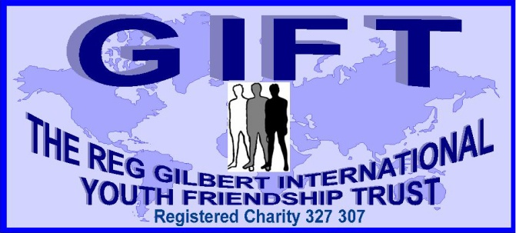**2014 CHAIRMAN’S REPORT**

For the past twenty eight years the fundamental and uncompromising ethos behind the GIFT Trust is to encourage and support young people to enrich their lives through direct contact with another culture, so as to gain a balanced perspective of other people in the world’s rapidly changing ‘global village’.

This year the Trustees have been able to allocate seventeen bursaries to young adventurers to live and work in a number of countries in Africa, Asia, and Central and South America. Each of them will have had to address the challenges of preparing for their visits before travelling, to often remote locations, to countries with alien customs and language. They then have to adapt to a ‘homestay’ environment and become part of an indigenous family for many weeks on end - before returning back to their familiar ‘western’ ways of life. These life-changing encounters provide a real educational significance that cannot be experienced in the classroom, from books, or on the internet. In a few short weeks of direct exposure to an alternative culture it will invariably test any pre-conceived perceptions, and allow them to make a mature assessment of the strengths and weaknesses of their own society

Almost 400 young UK citizens have now had an understanding of this direct interaction in a developing country through the GIFT system, and all that is asked in return is a report and realistic appraisal of what they have learnt from their experiences to help others considering similar visits. The reports, which are posted on our website, are often heart-rending, stark, and display the harsh realities of life in communities which do not enjoy the privileges and infrastructure that our society takes for granted. However, there are also many joyous things that come through. Even though many of the communities live with little or no materialistic possessions, they retain strong family bonds, traditions, community spirit, happiness and friendships, which sometimes are becoming under-valued within our own culture.

This unsolicited comment from one of our bursary holders, returning from Nicaragua, sums up the on-going GIFT criteria which encourages young people to go out and achieve. “Not only does GIFT encourage young people to become active in their own global citizenship, it goes one step further to ensure they get the most out of their cultural experiences. By adherence to the homestay value it immerses oneself entirely in a culture of learning to live and love the peoples of the world and their diverse ways of life. The depth of this commitment is a rare delight to benefit from, and is for me, a much more insightful and forward-thinking breed of philanthropy. Without GIFT this experience would not have not been possible for someone like me with such limited means”

It is hoped GIFT will support a number of 16-24 year old applicants again for 2014/15 Further information on the GIFT Trust and its objectives, with links for Application Forms and ways of donating to support future applicants, can be found on: [www.giftfriendshiptrust.org.uk](http://www.giftfriendshiptrust.org.uk)

Derek Harman-Trick, Chairman, and a founder Trustee of GIFT

*GIFT autonomously operates under the guardianship of the Rotary Club of Frome.*