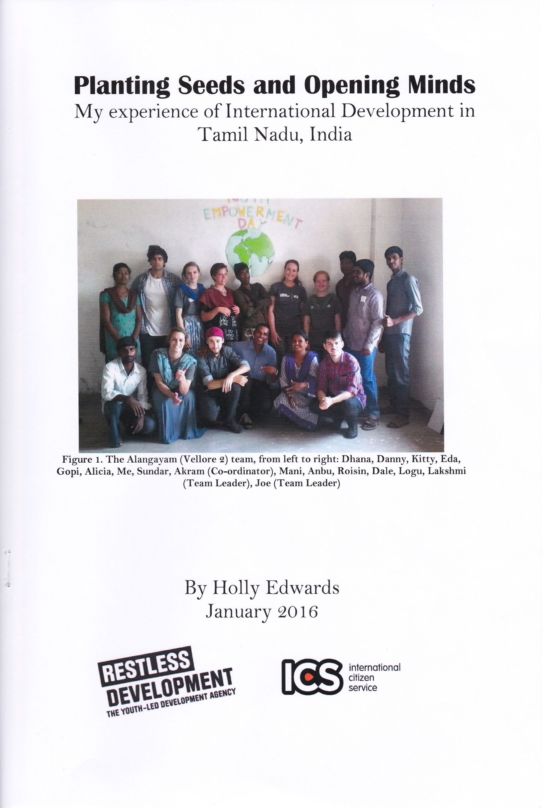
Introduction
Thanks to Restless Development, International Citizen Service (a programme run by the British Government), donations from friends, family and the community, and a generous sponsorship from GIFT, I was able to take part in a three month international placement with Restless Development in Tamil Nadu, India. This involved staying with a host family in the rural town of Alangayam and working with a group of seven British (international) and eight Tamil (national) volunteers, in cooperation with a wider network of three other similar placements in northern Tamil Nadu. Each placement was given two project foci: health and livelihoods. I chose to be part of the health team, working with nationals Dhanamlakshmi (Dhana), Anbumani Madhavan (Anbu), Gopinath (Gopi), and internationals Alicia Pearce and Eda Giray.
My placement was highly rewarding I was able to be part of amazing development work experience a different culture, gain loads of confidence, and meet some wonderful people. I learnt the importance of cultural exchange as a vehicle for transformation and change, not only for the local community, but also national and international volunteers. As a team we planted seeds of change in each other and the community, and opened our minds to new attitudes and ways of life, hence the title Planting Seeds and opening Minds.
A Warm Welcome
We received a very warm welcome from our host families (we had two host families as our residential host family was unable to provide food) and the entire street, the children of which brought us roses on our arrival. My first impression was that the house was much more spacious than other houses I had seen during our journey and in-country training and that there seemed to be a really strong sense of community in the street, with children from different houses playing together, with no clear definition between households.
As the placement went on I learnt that this sense of community is really strong in Tamil Nadu. Our national volunteers explained that 'brother' ("thambi")' and 'sister' ("Akkad") are friendly titles to relatives and non-relatives, a grave insult being "you are not my sister”, this resolved our confusion about the number of relatives everyone seemed to have! Our host father Harri was constantly away helping one brother or another, and our national volunteers Varalakshmi Mahendran (Lakshmi) and Dhana always put their sisters before themselves. When we explained our admiration of this sense of community to our host mother, she responded, surprised, "but we are a family!" and our street really was a family, if not by blood.
One way that this sense of community manifests itself most strongly is through food. As we walked around the town we were frequently asked "sapten glah?" by people, which means 'have you eaten?' and is used similarly to 'how are you?' in English. If you responded yes they then wanted to know exactly what you had eaten, how much, and whether you enjoyed it. This concern for whether we had eaten extended to huge generosity, for example when carrying out a survey on toilet use we were taken aback by the many offers of dinner we received, despite evidence of poverty. Of course, this feeding attitude often caused some embarrassing moments, for example at weddings and house warmings we attended any expression of enjoyment would result in second portions, which we had to eat to avoid offence!
As a keen cook myself it was really interesting to learn about and experience Tamil food, which is totally unlike any preconceptions I had about 'Indian food'. Some things that took getting used to were eating everything with my right hand and having noodles for breakfast (yum!). After some reluctance (they didn't want us to feel that we needed to help) our host family let us learn by getting involved with the cooking, I learnt to make my favourite peanut and coconut chutney, and had a go at rolling chapatti (although as mine was described as a "different chapatti" by Dhana I think I might have some practice to do...). We also learnt a little about the medicinal connotations of food in Tamil culture, which seemed strange to us, for example we not allowed our favourite: tomato chutney (a bit like salsa) during the cold weather because it would not keep away fever!
Through the welcoming attitude of a friendly community we were privileged to experience a great deal of Tamil culture. During our stay we were invited to four weddings, one engagement party, two house warming breakfasts, one coming of age ceremony, and two Diwali parties. Our host street and national volunteers were really helpful in making sure we didn't make complete fools of ourselves at these events, helping myself and the other women with dressing in our saris (something which was more complex than we expected!), and explaining what makes appropriate wedding gifts. They also taught us a lot about the meaning of festivals, for example explaining how the loud bangs we heard at Diwali were absolutely necessary to get the attention of the gods.
Our national volunteers really welcomed us into their lives and homes: during our stay we visited the homes of Sundar, Dhana and Gopi. The variety of lifestyles of our friends meant we could experience an insight into different ways of life: Sundar lives near the centre of town with commuting parents, Dhana close to relatives in a rural village, and Gopi in a quite isolated but huge and beautiful farm. They treated us with the usual warm Tamil hospitality: we had amazing food, and were even given a tour of the farm from Gopi and his family (including trying fresh green coconut straight from the tree and witnessing diving into a IOO foot well!).
Gender and Sanitation: Some culture shocks
I think it's fair to say we had a few culture shocks in India, and not the ones we were necessarily expecting (I at least quickly got used to Indian 'long drop' toilets we'd been warned about!).
What I think had the biggest impact was the different attitudes to gender and sexuality we experienced. We women found it surprisingly challenging to our personal expression needing to cover our shoulders, full legs, and wear a scarf over our chest, especially due to the uniformity in shape (although certainly not colour or pattern!) of Tamil clothing, which is far more conservative than in other Indian states.
However, I was more shocked by the restrictions placed, not just on women, but also young men, in our community. We were surprised to find that almost everyone we spoke to either supported the concept of arranged marriage, or were suffering from parental rejection as a result of their choice to marry for love, especially if the partner was someone from a different caste or religion. Whilst one national volunteer desired an arranged marriage (because his mother would be to blame if his marriage went poorly!), another volunteer had Iost contact with his family for marrying a Christian woman. We also met a female volunteer from another placement who was being forced to marry a cousin in another country, rather than pursue a PHD as she wanted. This restriction extended down to younger girls, and we had mixed feelings about the coming of age ceremony we attended of a sixteen year old friend in our street. Whilst her's was very late, most of these ceremonies take place in the early teens, and can have worrying links to child marriage, as they are sometimes considered to indicate that a girl is ready to marry. We also learnt that prior to this ceremony the girl must spend her first menstrual period indoors and may not socialise outside immediate family. Comfortingly, child marriage is a topic which my colleagues in the livelihoods team had great success, through puppet shows and other activities they showed girls how avoiding child marriage can lead to a better life for both yourself and your family, and were pleased to get a positive response.
I think the biggest shock I had on my placement however has to be the seeming acceptability and 'shushing up' of violence against women in our community. Having used the services of the friendly local tailor multiple times to finish our Tamil clothes, we were disgusted to be told not only that he had recently been released from prison for attempting to petrol burn his wife, but that we shouldn't tell anyone! A national volunteer also told us that the murder of an adulterous wife is often deliberately overlooked by police officers, and that men are often allowed to walk free for murder if they explain their motive to the police.
Whilst gender issues were certainly at the forefront of our thoughts, within the health team we experienced more directly culture shock about attitudes to sanitation and other health issues. What surprised (and frustrated) us was learning that whilst most people in the community were aware that drinking dirty water causes health problems, they are either unable (due to time or expense of fuel and bottled water) or simply unwilling (surprisingly common) to boil dirty water or purchase it filtered. Another problem we sought to tackle was the belief that defecating outside is better for you than using a toilet. People also face difficulties in accessing a toilet, as although a government scheme is available, it still requires a financial contribution and involves some complicated paperwork. We discovered from an interview with the Women's Self Help Group that in the neighbouring village only 3o% of people had access to a toilet. Therefore much of our work as a health team concentrated heavily on changing views about sanitation and providing assistance in applications for toilets through our #toilets4change campaign.
Planting Seeds: our work
As a placement team we: taught through non-formal learning at local schools, ran after school clubs for younger children, met with stakeholders (including the village president, women's' self-help groups and head teachers), and organised big events (including several at the hospital aimed at pregnant mothers). Essential to our work was being both an international and national team. Our national volunteers were amazing, not only as translators (although this was vital), but also to provide context and cultural relevance to all of our work. Involving volunteers from the local area also engages more young people in development for the future, making the work sustainable (many of our national volunteers told us that they initially got involved to improve their English, but were inspired by our enthusiasm to become passionate about sustainable development too).
That concept of sustainability was a big part of our whole placement, knowing that Restless Development had made the decision to no longer have a placement in Alangayam, we were keen to make sure the local community would be inspired to continue our work in the future. We did this through the Sustainable Development Goals (SDGs). The SDGs are a collection of 17 goals made by the UN this year to make the world a better place by 2030, and include goals such as Quality Education for All' and 'Responsible Consumption and Production'. Right at the beginning of our placement we held a Youth Empowerment Day where we introduced the SDGs to students at Imayam College, but, whilst the day went well, I don't think we'd quite 'got it' yet. In contrast, our final event, a Volunteer Empowerment Day at GSSR College, was for me the best thing I did on ICS. What really made it stand out is that we asked the students to get into small groups with an SDG to discuss what it means for the world, and, most importantly, how they themselves can apply that goal to their own community right now. I was astonished by the positive response we got and how many wonderful ideas the young women shared, some of them who were normally very shy stood up and shared. This youth empowerment of local people, especially of young women, is for me the essence of Restless Development and it gives me enormous hope for the future.
A Wake-up Call': the Chennai Floods
All good things, however, must come to an end. But I was never expecting to be evacuated. Although in our mountainous placement we saw relatively little of the devastation, we noticed the effects of the Chennai floods at first in frustrating disruptions to our work. Schools were closed for fear of roof collapse, children were not allowed to walk to school in the rain (as we found also from our national volunteers, getting wet is linked to catching fever in Tamil culture and strongly avoided), and our top-up training in Chennai had to be moved, resulting in the cancellation of a toilet application event of huge importance to our campaign.
But really we were naively isolated from the true extent of the disaster. It wasn't until our friends in other placements regained communication; we witnessed the drowned Chennai on the news, and began to see collapsed houses, that we became truly aware of the effects. We heard terrible stories from volunteers who knew relatives in lowland areas and in Chennai: people left heartbroken after losing loved ones, homes destroyed, and people trapped in houses unfit for residence relying on army supplies.
Many scientists are now proposing that the Chennai floods, which killed 3OO people and destroyed the lives of thousands, some of whom our national volunteers knew, were the result of human created climate change, and describe it as a "wake-up call" (Potarazu, 2O15 http:/ / edition.cnn.com /2015/ 12/ 19/opinions/potarazu-chennai-flooding/). For me this ‘wake-up call' was both a reminder of the potential results of climate change and a demonstration of the Indian government's failure to help its poorest citizens, as much damage could have been avoided with better infrastructure, and large parts of the recovery work had to be done by volunteers, including people we knew. Many people during my pre-departure fundraising asked why they should give money for someone to volunteer in a country with a space programme. For me witnessing of this incident, as well as the effects of poverty and poor sanitation in my host community, has demonstrated the necessity of continued international development in India.
Following the flooding of other placement houses, and of Chennai airport, Restless Development made the decision to evacuate us a week early and fly us out from Bangalore airport. Inevitably, this left us with mixed feelings. Whilst many of us, me included, were excited to see our friends and relatives, and other placements were struggling to live with flooding damage and the risk of further downpour, it was incredibly difficult leaving behind our new community and friends, especially knowing we could have helped with flood recovery efforts.
Things to Take Home
Having done all my Christmas shopping in India, I had a whole lot of stuff to take home, but I also had a lot to take home that didn't have to fit in my suitcase. I think the biggest things I will take home from my experience are the importance of a strong and loving community, learnt from my Tamil friends, and that a bit of confidence and a lot of perseverance can change the world, especially if you can inspire others to join you'
Useful Links
Restless Development: http://restlessdevelopment.org/
International Citizen Service: http://www.volunteeries.org/
The SDGs: https://sustainabledevelopment.un.orgl
Help flood victims in Chennai: http:/ /www.globalgiving.co.uk/projects/chennai-floods/
Get involved with improving sanitation around the world: http://www.wateraid.org/uk

