Intercalation project in Brazil: Bauru and beyond
As an intercalating medical student in International Health BMedSc, it was a curriculum requirement to perform a research project. The nature of the course encouraged students to endeavour abroad. The first semester was spent gaining familiarity with research methods and a bit of a global perspective on healthcare. Each student then wrote a research proposal that was assessed for strength, importance, safety and feasibility. I decided to focus on leprosy, a Neglected Tropical Disease (NTD) that can cause severe disability and poor quality of life if left untreated. Many people perceive leprosy to be an ancient disease that has been eradicated, which is the case in many parts of the world. Unfortunately it is still a significant burden in some countries. Of particular interest to me are the experiences of stigma faced by patients with leprosy, which previous research has shown to be an established norm in societies where leprosy is prevalent. My university has established links with a dermatology institute in Brazil, a country with the second highest rates of leprosy in the world. The institute is located in Bauru, in the state of São Paulo. Brazil is a fascinating county that is a mix of different cultures, social statuses, and mentalities. It is currently the sixth biggest economy in the world, suggesting increasing financial strength (and all the social changes that come along with it). I was interested in finding out whether these changes in Brazilian society have had any effects on the way patients with leprosy feel that they are perceived by others. I proposed a qualitative research project which would focus on the experiences of stigma by patients with leprosy, and how these may (or may not) have changed over time. This would be done by conducting interviews with patients who had been diagnosed with leprosy over twenty years ago (for a more historical view) and those who had been diagnosed much more recently (for the more recent picture).
While in Bauru I lived in hospital accommodation at the institute. A former colony and hospital for patients with leprosy, the institute is now a governmental research and referral clinic under the ministry of public health. The centre cares for patients with a range of skin diseases, but takes a specialist interest in patients with leprosy. It consists of both outpatient and inpatient departments. Many patients are still residents of the former colony by choice. A large number of patients, diverse healthcare staff and students all live on site and so this made for a vibrant and interesting experience.
The research project took some time to get started, as I was faced with the reality of my proposal going through the scientific and ethical committees at the institute. While it was frustrating to wait when I had already gone through this is process in the UK, it is important to respect the structures that a different country has in place. Additionally, going through rigorous checks from panels at two different organisations meant that I felt that my project was of a good standard. In the meantime, I became acclimatised to the way of life at the institute, and became familiar with the psychologist and other team members I would be working with. I was given a very Brazilian welcome. It was full of warmth, and made me feel that my presence was nothing if not treasured. I was introduced to family members, taken to parties, to country homes, dancing, cooked for, given presents and generally better looked after than I could ever have hoped to be. I found that Brazilians seem to be very willing to go out of their way to help. If I ever asked anyone for directions, they would stop whatever they were doing and take me to my destination. If I asked for the location of the bus stop, someone would offer me a lift instead. It was overwhelming. I also got the opportunity to pick up some Portuguese (which is a surprisingly difficult language in terms of grammar and pronunciation, and one that I was previously completely unfamiliar with).
Once the result of the scientific and ethical committees came through as successful, I was able to begin. The plan was to interview about 20-30 patients myself with the use of an interpreter and record the interviews. I was meant to use an interview guide for the semi-structures interviews, allowing me to ask important questions that I wanted to know but also enabling new and interesting topics brought up by the patients to be explored. It turned out that none of the team I was working with had sufficient English to act in this role. I took some initiative and decided that it would be more appropriate for the interviews to be conducted in Portuguese using my interview guide to stay true to the aims of research. Afterwards, the interviews were transcribed into Portuguese and translated into English. These English transcriptions will then be used to help write up my research project in dissertation style, and potentially for publication.
Regardless of the grade I attain from the dissertation, the experience of living and working in Bauru was one that I will never forget or regret and has been the biggest reward I could have hoped for. I was even able to travel through a few Brazilian states and experience more of the food, nature, music, and peoples. It was a wonderful experience and I am grateful to GIFT for the financial help that they have provided me with.
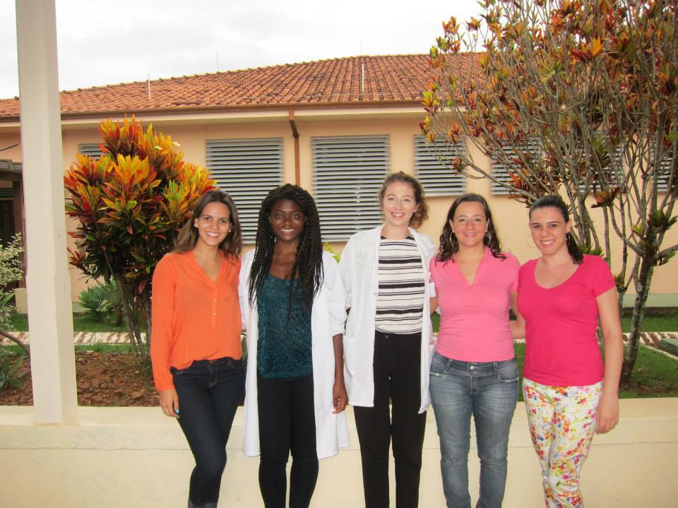

Sisan Sillo April 2015

